**Ex 3: Building & Using a Component**

Your task is to create a new MainGoal component which outputs a paragraph of text that describes your main course goal (e.g., *"My main goal: Learn React in-depth and from the ground up"*).

You'll have to create this new component from scratch and then use it inside the App component's JSX code.

The finished app could look like this:

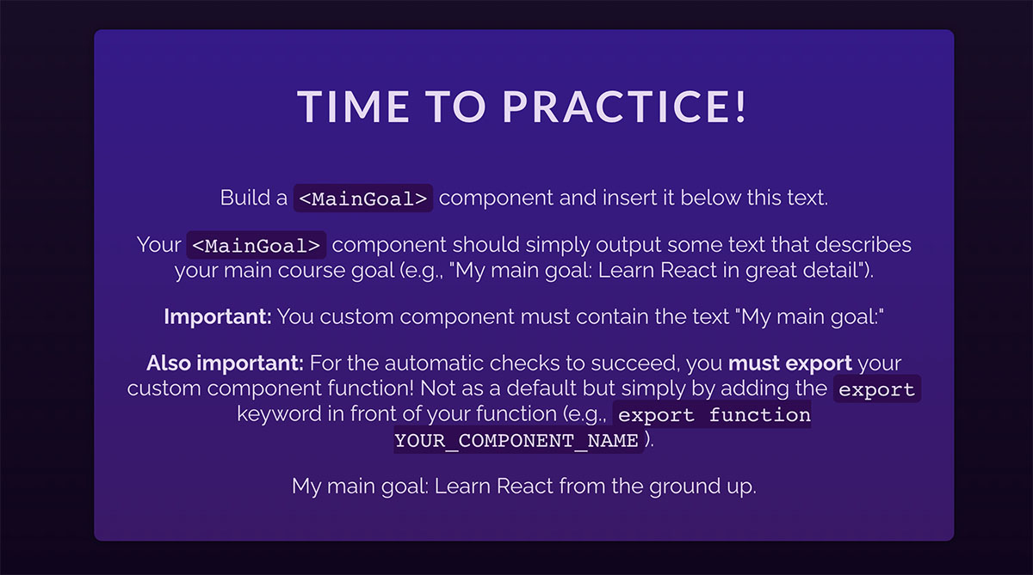

(notice the "My main goal: Learn react from the ground up" text at the bottom)

**Important:** To ensure that the automatic checks correctly detect your solution, your component **must be called** MainGoal and it also **must be exported**. To do that, simply add the export keyword in front of your MainGoal component.

The MainGoal component also **must contain the text** "My main goal:" (followed by whatever your main course goal is).